**Project**

**Lab Report**

**Project Details**

**Project Title:**

**Industrial network design in packet Tracer and employee attendance system using static IP and MAC**

**Course Name:**

Mobile Computing Lab

**Course Code:**

CSE 4204

**Submission Date:**

6 September, 2021

**Submitted to:**

**MD. Riaz Mahmud**

**Lecturer**

Department of **C**omputer **S**cience & **E**ngineering,

**Northern University of Business and Technology Khulna.**

**Submitted by:**

M. Ali Abrar Khan

ID-11170320121

Section- 8A

Department of Computer Science & Engineering,

Northern University of Business and Technology Khulna.

Md. Tahadur Rahman

ID-11170320115

Section- 8A

Department of Computer Science & Engineering,

Northern University of Business and Technology Khulna.

**Table of Contents**

Project Overview: 3

Project Objectives: 3

Github link: 3

https://github.com/MAliAbrarKhan19/EAMS-IP-MAC-based-Employee-Attendance-Management-System.git 3

Advantages: 3

Disadvantages: 4

Platform : 4

Project Status: 4

1. Web Part: 4

1.1 Requirements for Website: 4

1.1.1 HTML 4

1.1.2 CSS 4

1.1.3 Bootstrap 4

1.1.4 PHP 4

1.1.5 JavaScript 4

1.1.6 MySQL 5

1.2 Database Structure MySQL: 5

Tables that are given below represents the database structure of the website. 5

1.3 Front-end Structure : 6

Given below are the front-end structures of the website. 6

7

2. Network Part: 7

Devices and Technologies: 7

2.1 Devices 7

2.1.1 Switch 7

2.1.2 Router 7

2.1.3 Firewall 8

2.1.4 IP Phone 8

2.1.5 Servers and Hosts 8

2.2 Technologies 8

2.2.1 Access Control Lists 8

2.2.2 VLAN 8

3 Design and configuration 9

3.1 Requirements 9

3.1.1 FUNCTIONAL REQUIREMENTS 9

4. Topology 9

4.1 Physical 9

4.2. Logical 9

4.2.1 Logical Figure in Packet Tracer 10

Conclusion: 11

Future Work: 11

# **Project Overview:**

A computer network is a group of computer systems and other hardware computing devices connected through communication channels to enable communication between a wide range of users to share resources. The implementation of a corporate network scenario is completely network based. IT is a secure network that is mostly used in major organizations and other entities to ensure secure connectivity and exchange of their data, information, the building blocks of computer networks are specialized equipment such as hosts, routers, switches, and access points. A network is created when two or more of these devices are connected to exchange resources via a common convention known as protocols.

Local Area Network or LAN (Local Area Network) is a type of network that serves a local area and supplies networking capability to a group of computers near each other. A local area network can support as little as two or three users in the home office or several hundred users in the central office of a company. Homeowners and IT managers set up LANs such that network nodes can share services such as printers or network storage.

In this project we are designing an industry network. It is a secured network often used in big organizations and other institutions to make a secured communication and sharing of their documents, files, etc. This network connects the different department of a company or many companies and combines them in a single network.

At the same time there is an attendance system for employees. This system takes attendance through their IP and MAC.

# **Project Objectives:**

* Every department of an industry will be connected to each other.
* The attendance record of each employee will be recorded by their static IP.
* An Industry Network design has been Secured.
* When an employee is coming to the office and when he is going will be recorded in Website.
* Every computer in the industry will be connected to each other.
* Every employee will be able to chat and share files with each other.

# **Github link:**

### https://github.com/MAliAbrarKhan19/EAMS-IP-MAC-based-Employee-Attendance-Management-System.git

## Advantages:

* When an employee is coming to the office and when he is going will be recorded in Website.
* It’s smart system for employee attendance system.
* Every employee will be able to chat and share files with each other.

## Disadvantages:

* It is totally network based so it’s need to internet for access.
* Every employee needs to switch on your own computer for attendance.

# **Platform :**

Packet Tracer,PHP, Java script, HTML, CSS, MySQL, Bootstrap

# **Project Status:**

Progress of our project is divided in major two parts:

1. Web Part

2. Network Part

# **1. Web Part:**

## 1.1 Requirements for Website:

This part gives an overview of what tools were included in developing the MAC & IP based Employee Attendance Management System (**EAMS**).

## 1.1.1 HTML

HTML (Hypertext Markup Language) is the code that is used to structure a web page and its content. For example, content could be structured within a set of paragraphs, a list of bulleted points, or using images and data tables.HTML gives authors the means to: Publish online documents with headings, text, tables, lists, photos, etc. Retrieve online information via hypertext links, at the click of a button.

## 1.1.2 CSS

CSS is the acronym of “Cascading Style Sheets”. CSS is a computer language for laying out and structuring web pages (HTML or XML). This language contains coding elements and is composed of these “cascading style sheets” which are equally called CSS files

## 1.1.3 Bootstrap

Bootstrap is a framework to help you design websites faster and easier. It includes HTML and CSS based design templates for typography, forms, buttons, tables, navigation, modals, image carousels, etc. It also gives you support for JavaScript plugins.

## 1.1.4 PHP

PHP (Hypertext Preprocessor) is known as a general-purpose scripting language that can be used to develop dynamic and interactive websites. It was among the first server-side languages that could be embedded into HTML, making it easier to add functionality to web pages without needing to call external files for data.

## 1.1.5 JavaScript

JavaScript is commonly used for creating web pages. It allows us to add dynamic behavior to the webpage and add special effects to the webpage. On websites, it is mainly used for validation purposes. JavaScript helps us to execute complex actions and also enables the interaction of websites with visitors.

## 1.1.6 MySQL

MySQL is a relational database management system based on SQL – Structured Query Language. The application is used for a wide range of purposes, including data warehousing, e-commerce, and logging applications.

# 1.2 Database Structure MySQL:

### Tables that are given below represents the database structure of the website.

|  |  |
| --- | --- |
| Employee_Table | |
| Primary Key | Id (Auto_increment) |
|  | employee_name |
|  | employee_email |
|  | employee_pass |
|  | employee_ designation |
|  | employee_ip |
|  | employee_mac |
|  | employee_mobile |
|  | employee_address |

|  |  |
| --- | --- |
| Attendance_Log_Table | |
| Primary Key | Id (Auto_increment) |
|  | date |
| Foreign Key | employee_name |
|  | log_ip |
|  | log_mac |
|  | employee_ login_time |
|  | employee_logout_time |
|  | employee_current_status |

# 1.3 Front-end Structure :

### Given below are the front-end structures of the website.

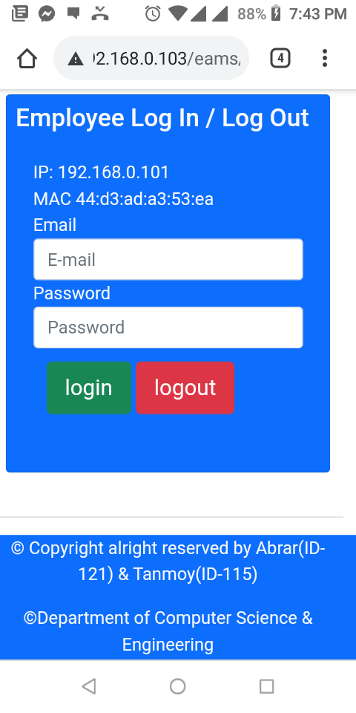Figure 1: Mobile Login look

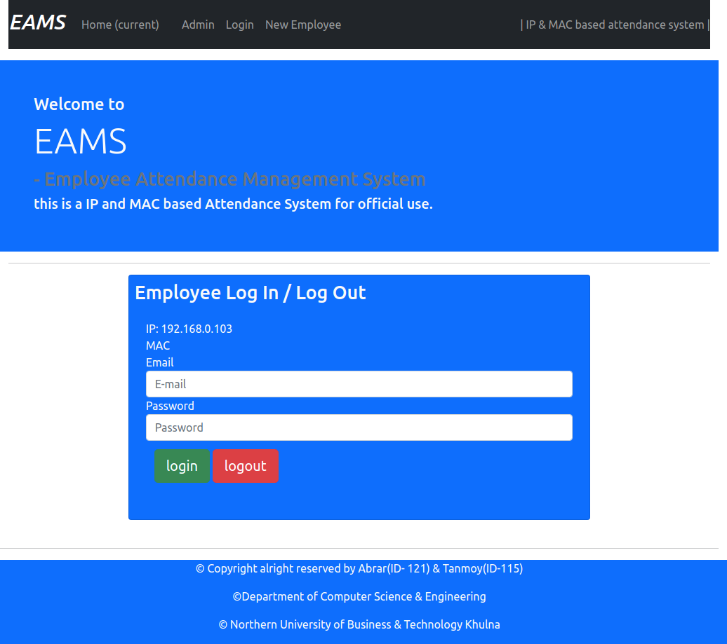Figure 2: Login Logout page for employees

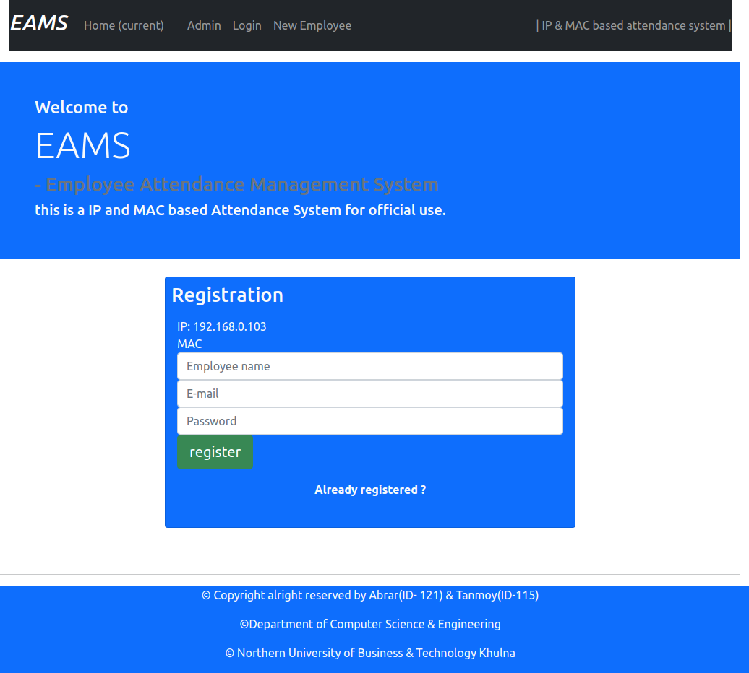Figure 3: New employee registration for admin

### 

# **2. Network Part:**

## Devices and Technologies:

This part will give an overview of the devices and configurations selected for the proposed design.

## 2.1 Devices

According to McQuerry (2008), the devices that transmit and/or receive data through a network segment are network devices. There are various devices used in the implementation of network design in accordance to the requirements.

### 2.1.1 Switch

A switch is used to connect several nodes of a network within multiple segments (Hucaby, 2014). This device works on the 2nd Layer of the OSI Model. Also, this device transmit data to the recipients except for broadcast traffic to devices with unknown ports. This device eliminates the remaining segments of a network from unintended procession of data and is imperative to network security and performance (Hucaby, 2014).

### 2.1.2 Router

Lucas (2009) stated that routers are interconnection network devices that send and receive packets between networks. This type of network device is based on Layer 3 IP addresses and selects the best path for data transmission in a network. This device, while on the 3 rd Layer of the OSI Model, makes network address- based decisions.

### 2.1.3 Firewall

According to Sheth & Thakker (2011), a firewall, is considered as a single device, which imposes the access control policy among networks. Firewalls, usually a standalone device, is an application software based or network embedded device.

### 2.1.4 IP Phone

IP Telephone, very broadly speaking, is a telephone built to operate with an IP PBX. However, the prevalence of the SIP standard means that the IP PBX of today has invariably develop into a SIP-based PBX. This is excellent news for companies and end-users because it ensures the PBX providers cannot push you to lock in with their proprietary applications or hardware.

### 2.1.5 Servers and Hosts

The host is a node that interacts in a user program, either as a server, a client, or both. The server is a type of host that provides services to other hosts. Usually, a server allows connections from clients who request a service feature (Jorge, 2019).

### 2.2 Technologies

This is known as entities for both material and irrelevant, created by the application of mental and physical effort to obtain some value. In this use, technology applies to instruments and devices that can be used to solve world problems.

### 2.2.1 Access Control Lists

The Access Control List is a policy used in filtering routing protocols, permit or deny traffic flows, and to redirect traffic based on the set policy. Also, this policy or rules is processed from top-to-down until it hits the first match. The access list is then processed only when a condition is met (Suman & Agrawal, 2016).

### 2.2.2 VLAN

Virtual Local Area Network (VLAN) is a standard of logically segmenting devices on a network that are physically dispersed (Froom et. Al., 2010). This standard allows network design to be flexible. Similarly, VLANs broadcast domain borders on the 2 nd layer of the OSI Model. These broadcast Domains are device groups, that receive broadcast frames created by devices in the group (Kaluve et. Al., 2008).

# 3 Design and configuration

## 3.1 Requirements

### 3.1.1 FUNCTIONAL REQUIREMENTS

* The three departments should have separate LAN with individual applications. However, these departments must share data.
* The company should be able to run both voice and data over VLAN.
* The design should support email and communication
* The design should also support a database server
* The design should also accommodate the company’s intranet

### 4. Topology

Network Topology: Network topology is the configuration of the different elements (links, nodes, etc.) of the communication network. This is a topological structure of a network that can be presented either physically or logically.

### 4.1 Physical

Physical topology shows the configuration of various network components. It represents the spatial configuration of the equipment and cables in the context of a network. It concerns the basics of a network that lacks minute information such as data transmission and system sort. The pattern of layout of nodes (computers) and network cables depends on the ease of installation and network setup. It affects the cost and capability of the bandwidth depending on the system solution. This considers the location of nodes and

the distance between them. Devices may be arranging to form a ring (Ring topology) or a linearly connected to a line called Bus topology.

### 4.2. Logical

A logical topology is a networking term that specifies the connection process configuration for all nodes within the network. It transfers data via Physical topology. It is independent of the spatial topology and the configuration of nodes. It involves the intricate specifics of the network, such as the type of devices chosen (switches, routers) and their efficiency, which influence the pace and speed of transmission of data packets. Logical topology guarantees maximal flow control that can be controlled within the network. However, the

mesh network topology is implemented, which enables redundancy across the network.

### 4.2.1 Logical Figure in Packet Tracer

(See below)

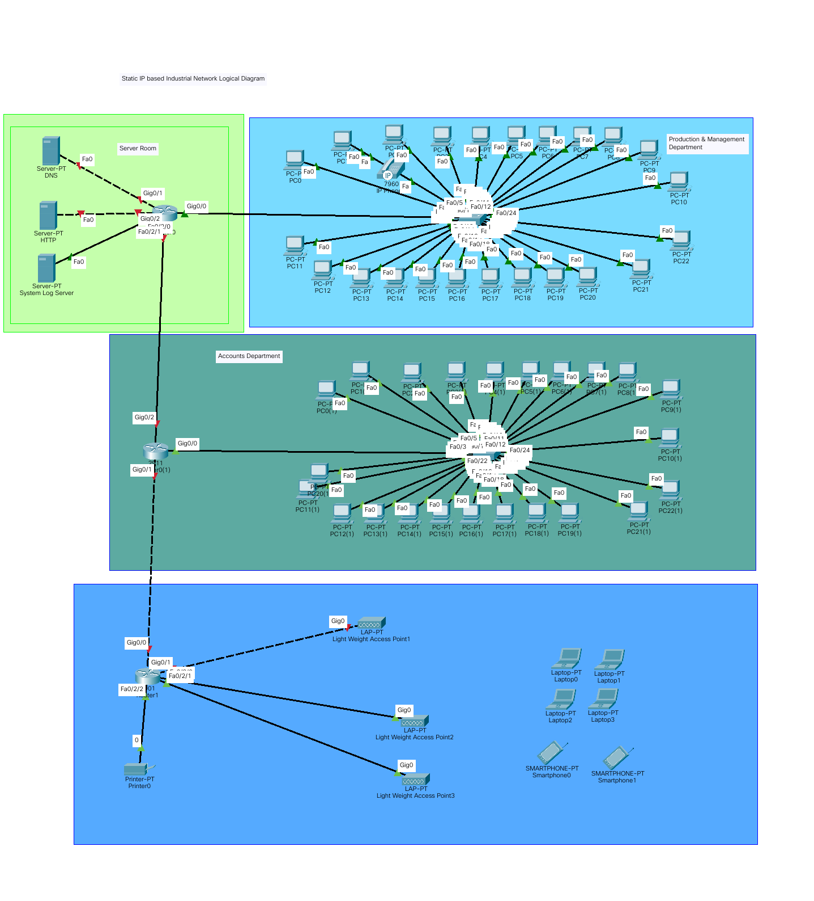

# **Conclusion:**

At last we can tell, it's a smart network design for an industry and this website is very useful for employees attendance. If anyone wants to see the record of employees when he is coming to office and left to office.

# Future Work:

* Payroll system
* Salary management